"Vegetable farming key source of women earnings"
Success story of Indra Balayar
Samabeshi Farmer Group, K.I. Singh rural municipality ward no-6, Bhumirajmandu, Doti

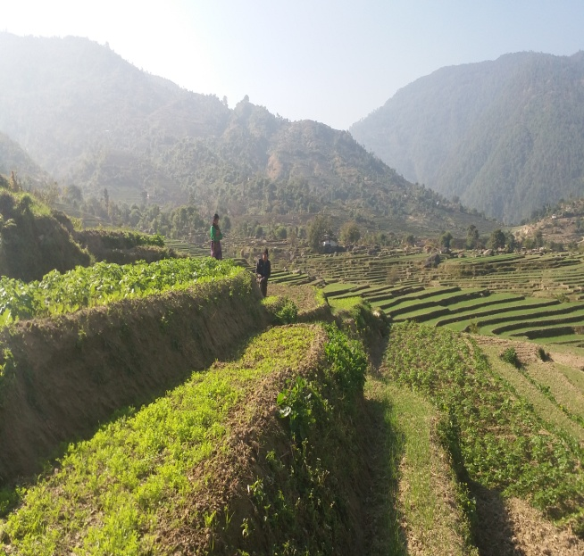
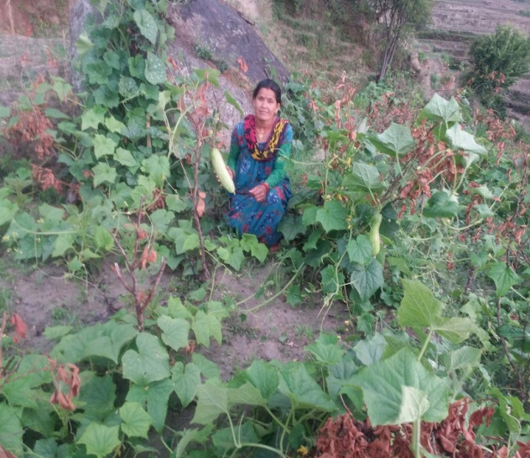
Indra Balayar 42 years old women living in K.I. Singh rural municipality ward no. 6 Bhitadi , Doti. Her family living jointly, 10 member families includes husband, 4 sons & 1 daughters, brother in-law, sister in-law and mother in-law. Her house is located in the foothills of KI Singh RM, Bhumiraj mandu. The family has 3 Ropani (1525.5 Sq. meters, 1ropni=508.5 Sq. meters) land as a main source of family food. In the past they focused on cereal cultivation in their farm but it was not even enough to feed the family her family daily life has not trouble-free. "Indra says after cereal crops farming my daily life so bad because lack of food security and cash". Her husband runs a seasonal migration in the India but the income from the minimum is really minimal as compared to the family require.
Indra Balayar Showing fresh cucumber in her farm,
Photo Bhumika Mahara ,EDC/SLP, JTA

Indra Balayar became a member of Samabeshi farmer group reformed by DCA supported EDC/SLP- Project, Nowadays she is president of farmer group. She received Commercial vegetable production training, home garden management orientation, participated integrated pest management orientation, and fresh vegetable production trainings. She got some material supports too by, vegetable seeds, plastic tunnel, plastic pond watering can, garden pipe .With regular technical guidance from project staff she is able to change her traditional cereal producing plots full of different vegetables, both in season and of season.
Indara Balayar, vegetable farming field
Photo: Bhumika Mahara, EDC/SLP, JTA

Before she was only vegetable farming in consume level. After DCA supported EDC/SLP project support, her 3 ropani of land has been converted to a well-managed vegetable farm able to produce different species like cabbage, potato, tomato, cucumber, radish, Green leaf and cauliflower. This has made her capable to produce quality seasonal as well as offseason vegetables. She happily says, "I have earned Rs. 34000 thousand from vegetable sale in this season and it will go up next year". Besides her commercial vegetable plots, her home garden has a good home garden containing diverse types of vegetables, fruits and livestock managed integrated. Now her earning from 3 ropani land is not only enough to feed her family but she is able to save some money out of it. In question about her future plan, she replied "Commercial vegetable farming increasing income and time use of productive so I want to continue vegetable cultivation in future as well" ". Indra has become an example for the youth women around K.I. Singh RM ward no. 6, Bhumirajmandu, Doti,. Her story inspires them to believe agriculture as an alternative for income generation.

Prepared by:
Ramesh Bhul
Project Coordinator
Bhumika Mahara
JTA

